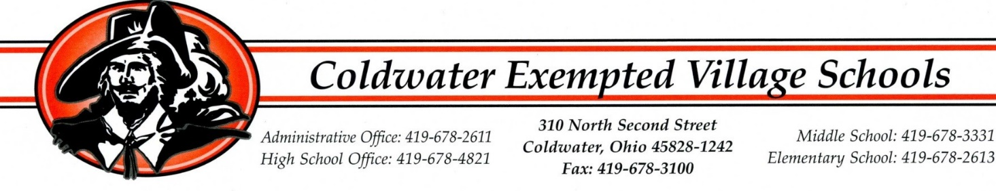
NOTICE TO HOUSEHOLDS THAT ARE or HAVE APPLIED FOR FREE/REDUCED PRICE MEALS
For the 2023-2024 Program year.

Dear Parent/Guardian,
Below is a statement from the Ohio Department of Education.
“The Ohio Department of Education is thrilled to announce the State of Ohio FY24-FY25 biennial budget includes funding to cover the cost of providing no-cost breakfast and no-cost lunch to students qualifying for reduced-price meals. Starting in school year 2023-2024, the budget language requires public and chartered nonpublic schools that participate in the National School Breakfast or Lunch Program to provide a breakfast or lunch at no cost to each student eligible for a reduced-price breakfast or lunch. The state will then reimburse the schools 30 cents per reduced-price breakfast served and 40 cents per reduced-price lunch served. On the effective date of Oct. 3, 2023, the budget bill requires all participating schools to provide the no-cost meal to each eligible student although schools may and are encouraged to start the school year without collecting money from reduced-price students.
Schools will continue to certify students for free or reduced meals and count and claim meals as free, reduced or paid. Schools simply will not collect money from reduced-price eligible students starting in school year 2023-2024. The Department will share additional updates as the process for reimbursing schools for the reduced-price breakfasts and lunches served is finalized.”
With that being said, you will still need to apply for free/reduced meals like you normally do. The Food Service Director at school, Ashley Ahrens, will go over all applications and notify you as soon as possible about your eligibility. This funding does go through the school year 2024-2025, but new applications will need to be filled out after July 1, 2024 for the following school year. If you want to discuss it further with Ashley Ahrens, please reach out at the number below. School Fees are not waived for these reduced meals that are now waived free. Their school fees will still be paid.
If you are not eligible now but have a decrease in household income, become unemployed, have an increase in household size or become eligible to receive Supplemental Nutrition Assistance Program (SNAP) or Ohio Works First (OWF) funds, complete an application at that time.
Sincerely, Ashley Ahrens
Coldwater Cafeteria Food Service Director 419-678-2480

